`
Application Load Balancer (ALB) Setup Documentation

1. Introduction
This document explains the steps to configure an AWS Application Load Balancer (ALB) to distribute incoming traffic across EC2 instances running in private subnets within a VPC.

2. Services Used
- Application Load Balancer (ALB)
- Target Group
- EC2
- VPC
- Public & Private Subnets
- Security Groups

3. ALB Architecture
Internet
|
Application Load Balancer (Public Subnet)
|
Target Group
|
Private EC2 Instances (Private Subnet)

4. Prerequisites
- VPC with public and private subnets
- EC2 instances running in private subnets
- Internet Gateway attached to the VPC

5. Create Target Group
- Go to EC2 → Target Groups
- Click Create target group
Configuration:
- Target type: Instance
- Protocol: HTTP
- Port: 80
- VPC: my-first-vpc
- Health check path: /
✅ Register private EC2 instances
✅ Create target group
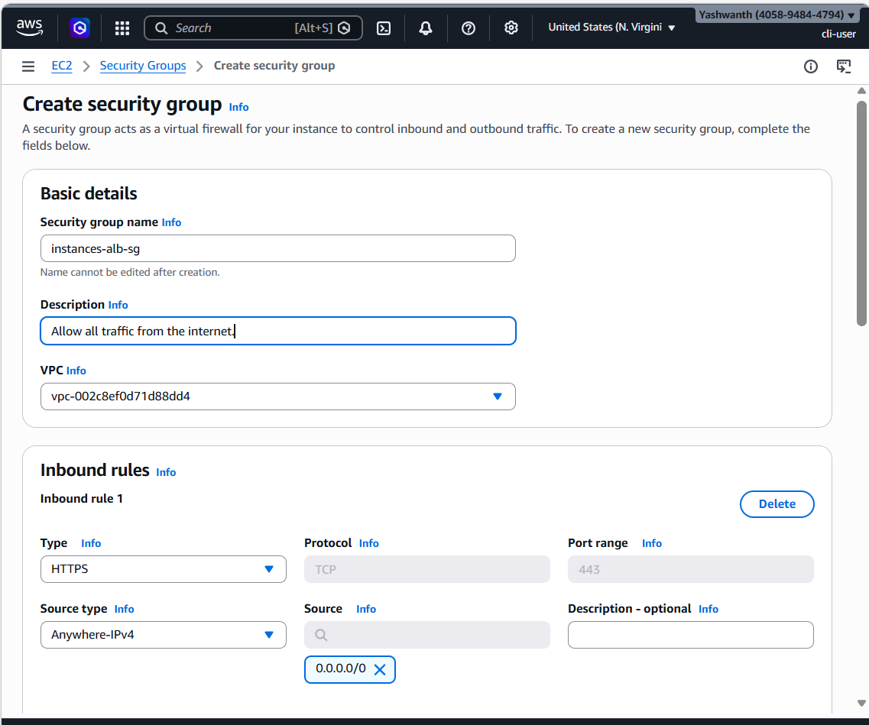
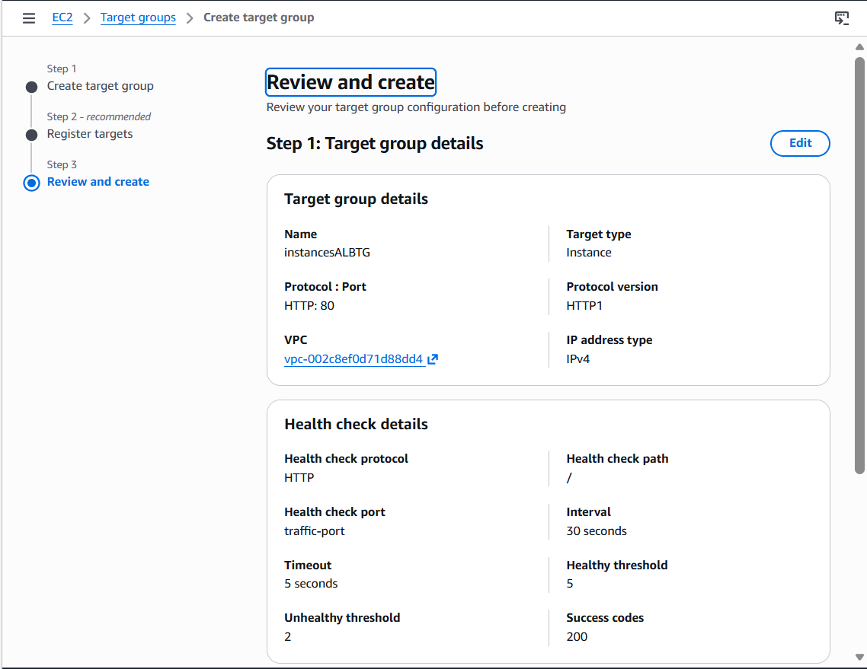

6. Create Application Load Balancer
- Go to EC2 → Load Balancers
- Click Create Load Balancer
- Choose Application Load Balancer
Basic Configuration:
- Name: my-alb
- Scheme: Internet-facing
- IP type: IPv4
Network Mapping:
- VPC: my-first-vpc
- Subnets: Select public subnets
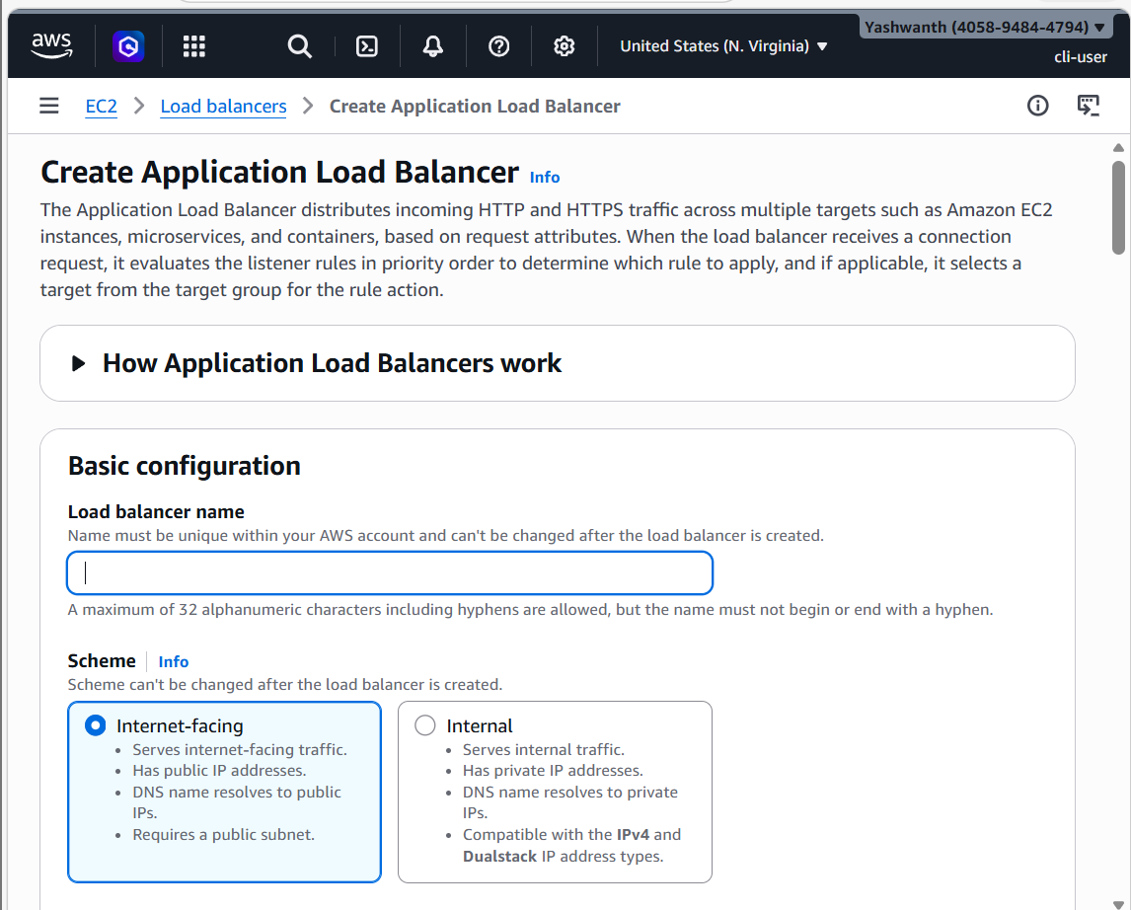
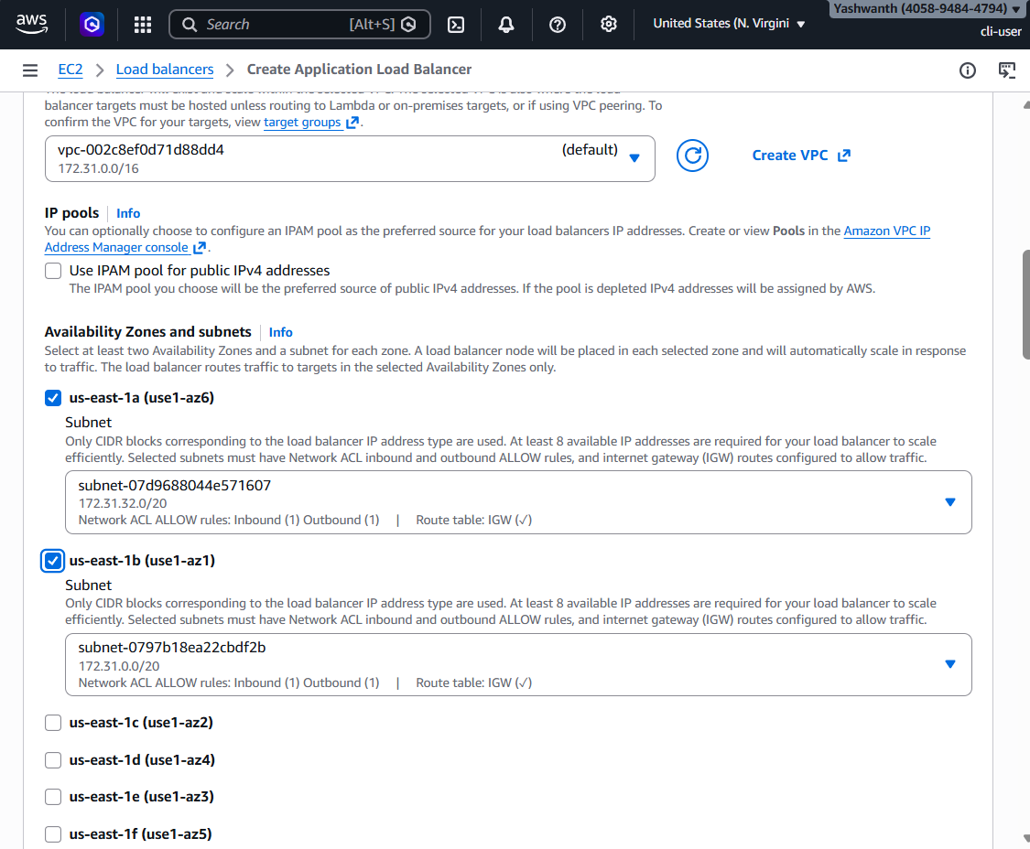

7. Configure Security Group (ALB)
Allow:
- HTTP (80): Anywhere (0.0.0.0/0)
- 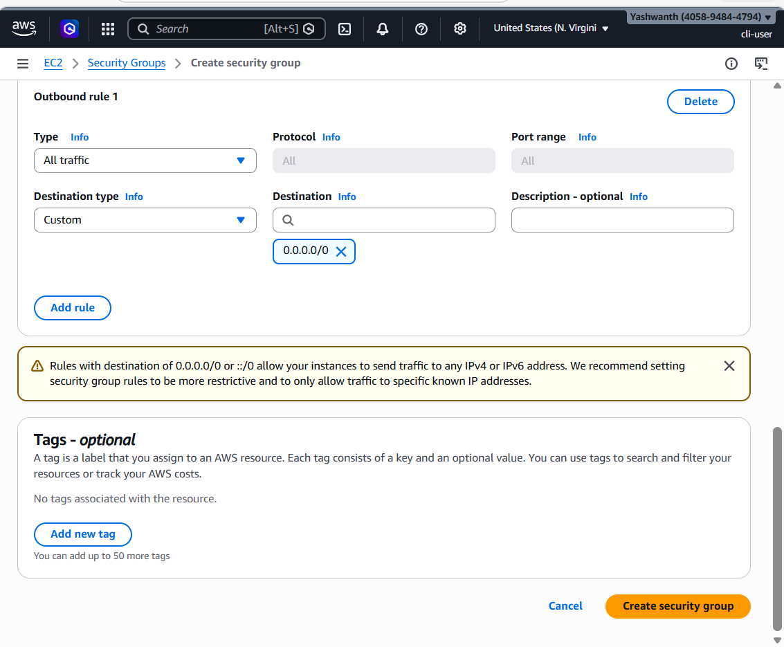

8. Listener Configuration
- Listener: HTTP : 80
- Forward to: Target Group
- 
✅ Create ALB
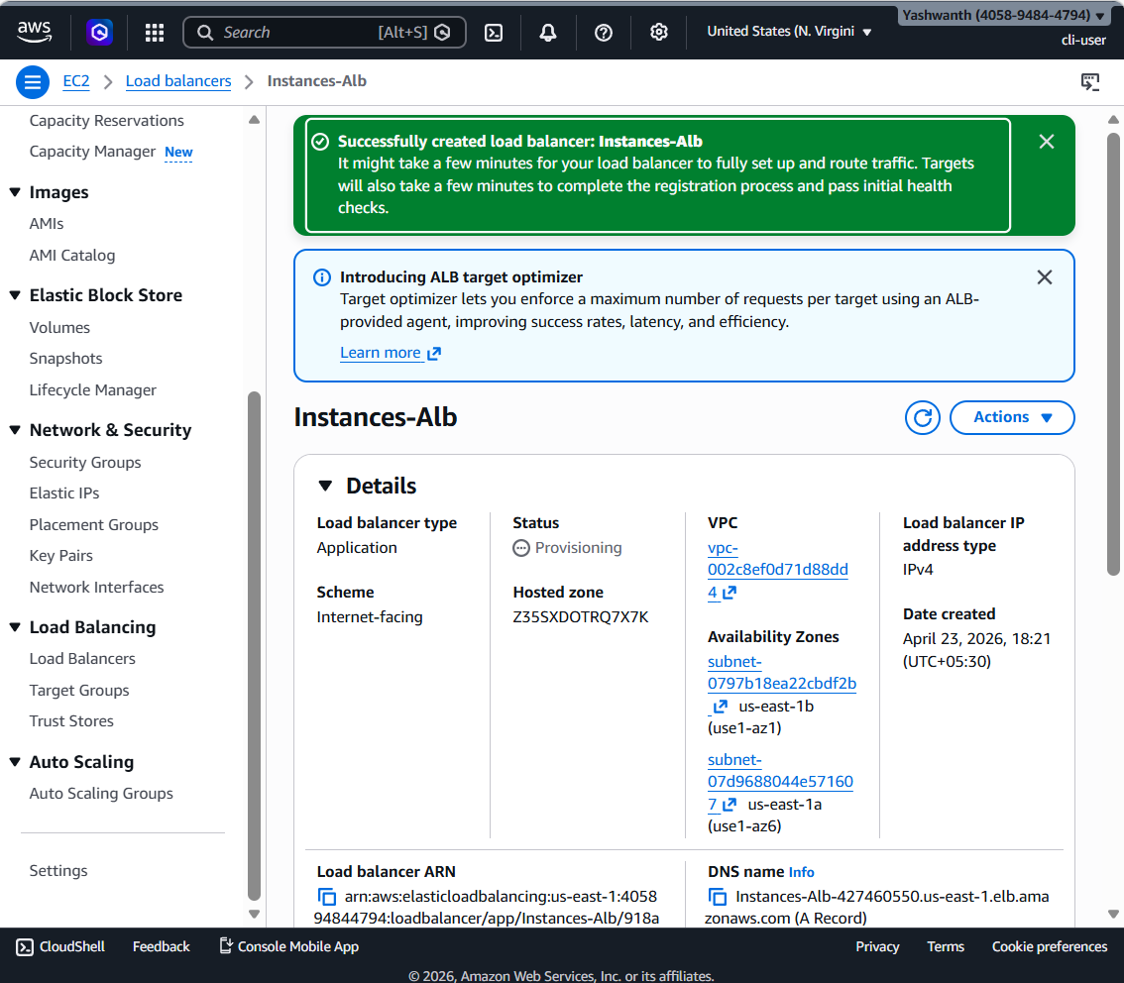
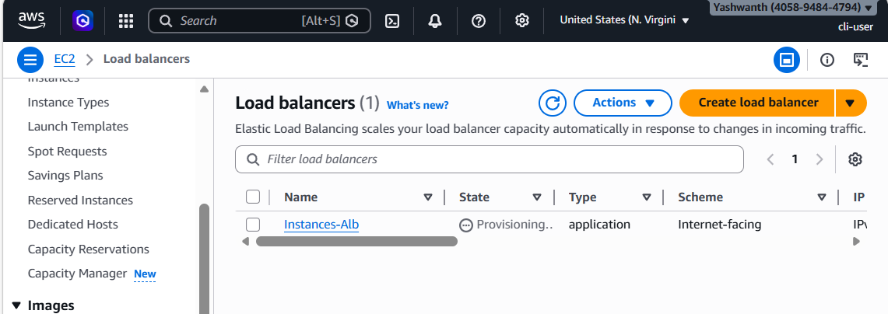

9. Security Group for Private EC2
Allow:
- HTTP (80): From ALB Security Group
- SSH (22): From Bastion Host (optional)

✅ Traffic is distributed to private EC2 instances automatically

11. Conclusion
The Application Load Balancer provides high availability, scalability, and secure access to applications running in private EC2 instances by routing traffic through public subnets.

